Seesion-2 Defect Report & Bugzilla Hands-On
Q-1. Create a Bugzilla account using your college or personal email, then log in and take a screenshot of your Bugzilla dashboard after successful login.
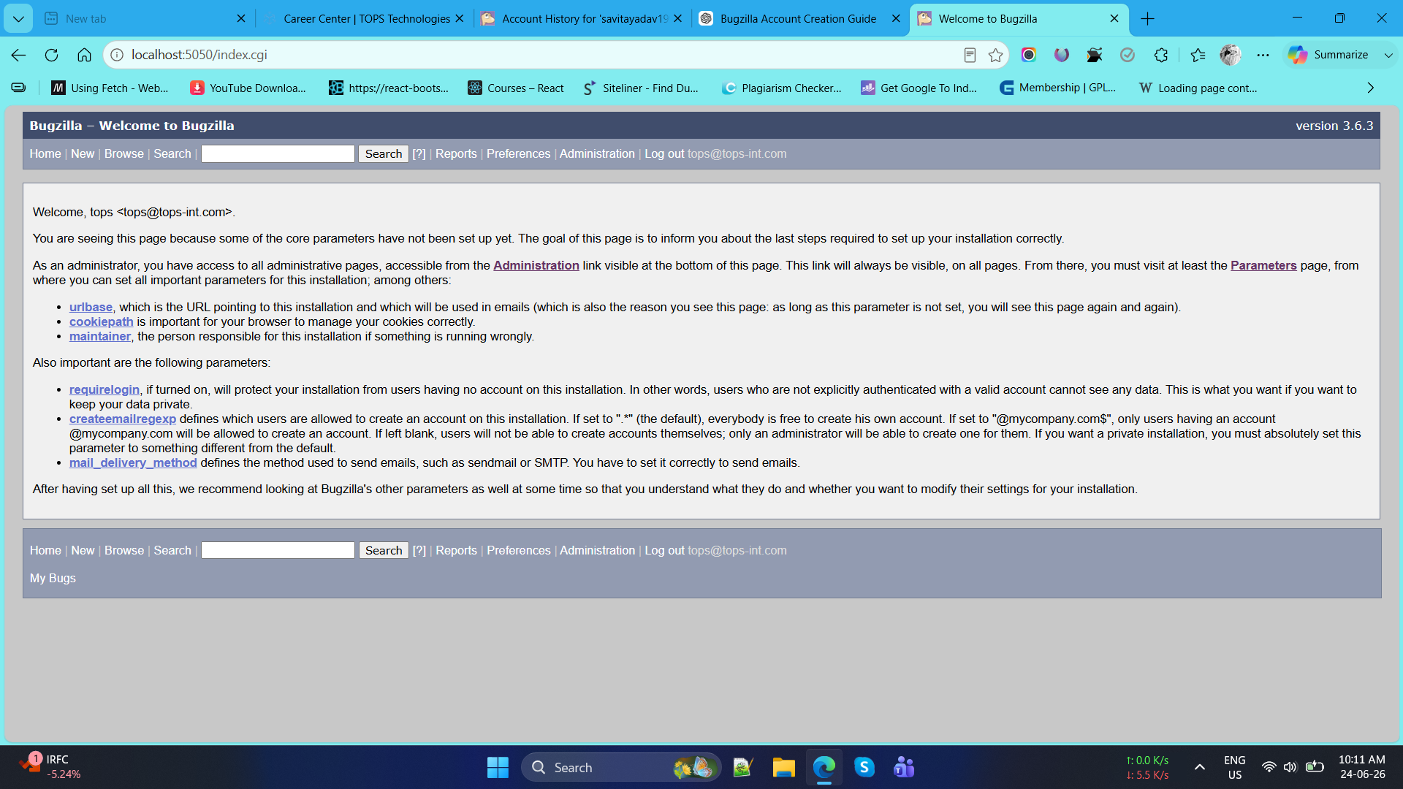
Q-2. Pick any mobile app you use daily (such as Instagram, Zomato, or Paytm) and identify a real or imagined bug you have experienced — log this bug in Bugzilla with a clear summary, detailed steps to reproduce, expected vs actual result, and attach a screenshot or mock image showing the issue.
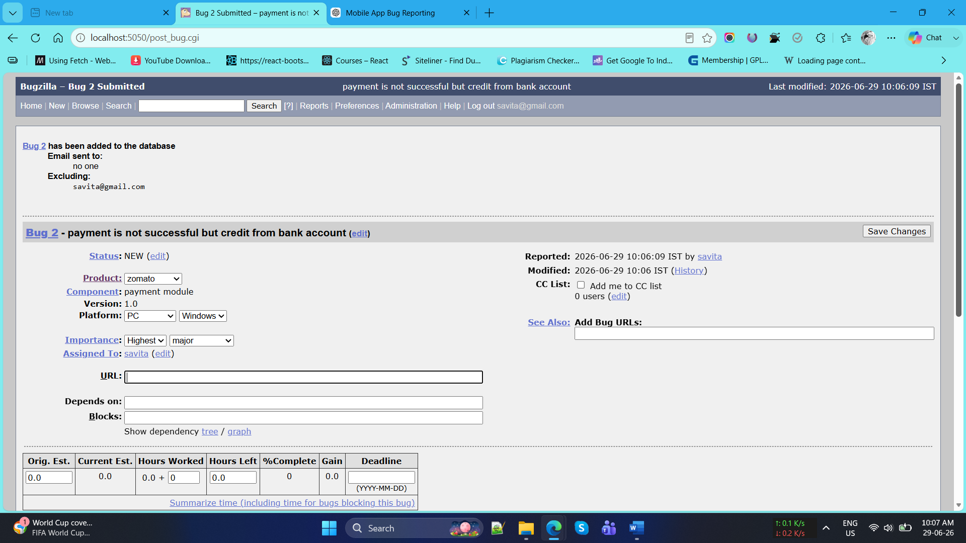

Q-3. Log two more defects in Bugzilla for different apps (for example, a payment failure in PhonePe or a wrong item added in Flipkart cart), making sure to select appropriate Severity and Priority for each defect and fill out the Module and Build/Version fields.
Ans.
Defect: Payment Failure in PhonePe
Product
PhonePe Mobile App
Component / Module
UPI Payment Processing
Build / Version
PhonePe v25.06.10
Summary
UPI payment fails with "Transaction Failed" message despite stable internet connection.
Severity
Critical
Priority
High (P1)
Q-4. Update the status of one of your logged defects in Bugzilla from 'New' to 'Assigned', then to 'Fixed', 'Retest', and finally 'Closed', adding a brief comment at each stage describing what happened. Hint: Use the 'Add Comment' box in Bugzilla to note what action was taken at each step.

New | Defect logged after verifying the payment failure issue on PhonePe v25.06.10. Issue reproduced consistently on Android 14 device.

Assigned | Defect reviewed by the project lead and assigned to the UPI Payment Processing development team for investigation and resolution.

Fixed | Root cause identified in payment gateway response handling. Code changes implemented and committed. Fix deployed in build v25.06.11 for testing.

Retest | QA team retested the defect using build v25.06.11. Payment transactions completed successfully without any error messages. No related issues observed.

Closed | Retesting completed successfully. Expected results achieved and defect verified as resolved. Defect closed.

Q-5. Use Bugzilla's search and filter features to find all defects you have logged that are currently not 'Closed', and take a screenshot showing the filtered results. Hint: Try filtering by your user ID and by defect status.
